**Business case**

* **Exclusive summary**

As the advance of machine learning technology became a growing trend in computer science. The implementation of sentiment analysis is easy to achieve nowadays. As thousands of information is generated on social media every second, the sentiment analysis made it possible for businesses to understand their customers' opinions and feelings more than ever. Therefore, a business could improve products and services more effectively based on the analysis results. Moreover, the algorithm of sentiment analysis will be more and more accurate and efficient along with each execution.

* **What**

Getting to know people’s feeling is important for businesses, politicians, and some other potentials since people could express themselves more openly than ever through the Internet. Thereby, we aim to develop a sentiment analysis application named ‘News tone’, which could identify the polarity of given text material. It could distinguish whether an expressed opinion or position in a given content is positive or negative. These expressions not only include customer feedback, but also could be social media conversations, news reports, and many other types of content. Sentiment analysis could automatically classify information in different types of intent. Of course, all these processes are not finished by human but machine learning technique – a highly advanced computer technology which has been improved considerably in recent years. As we know, a Human being can simply identify the polarity of a word, a clause, a sentence, or a paragraph but a machine cannot. A deep learning algorithm will firstly be trained with an infinite number of materials. The purpose of this is to ensure the machine could extract the subjective information and identify the polarity of a certain material correctly just as human do. Then, the analyzing algorithm can be applied again and again to analyze the information it received. By analyzing materials, the deep learning algorithm will constantly improve the performance of itself time by time to become more accurate and efficient. Afterwards, the outcome of sentiment analysis would be addressed clearly and explicitly in a visual form.

Figure 1 A sentiment analysis example

* **Why**

With the rise of the Internet and the emergence of social media, people could easily express their attitude and opinion through the network at any time. A great deal of information is keeping generated for a certain topic with time elapsing. Although, it is a vital channel to connect to people’s mind to understand their feelings and opinions. A huge amount of information is still a new breed of a challenge for the human to process and analysis. However, based on the advances of deep learning techniques improved considerably within recent years. Contextual mining becomes a possible solution to analyse sentiment among this information. Sentiment analysis could identify and extract subjective information from the source materials.

For instance, the figure shows below is a Twitter user who complained about the high price of Uber. It is easily identified by a human. However, there are thousands of these types of information generated and spread on the Internet. A human can't process and identify. However, these types of information are vital for Uber due to the information relates to their service. How could Uber extract all the relevant information on Twitter to understand their customer and improve their service? The sentiment analysis seems to be the possible solution to handle the situation like this.

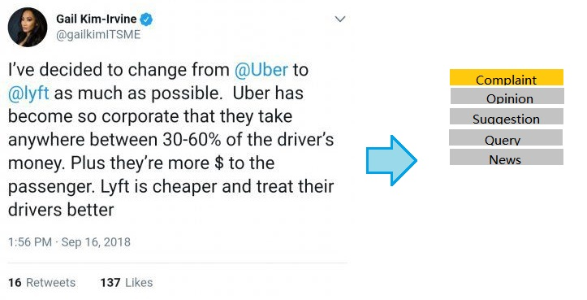

Figure 2 Analyzing intent of textual content

* **Goals**

We aim to create a sentiment analyzing program which identifies the polarity of certain text material from 'news.com.au' and delivers the outcome precisely and clearly. The objective is to extract the subjective information from the input material and identifies the polarity automatically, whether it is positive or negative. The result of the sentiment analysis will be compared with human's identifications for the same information to assess the program.

News tone

Iteration 1 Plan

# 1. Key milestones

|  |  |
| --- | --- |
| **Milestone** | **Date** |
| Iteration start | 30/03/2020 |
| Information extraction | 03/03/2020 |
| Information analysis | 04/05/2020 |
| Outcome presentation | 28/05/2020 |
| Iteration stop | 12/06/2020 |

Information extraction involves a web crawler-liked tool which could search and grab information from the Internet for analysis purpose. Information analysis is a vital part of the project. It provides sentiment analysis which includes text classification, subjective information identification, and sentiment analysis. Outcome presentation is the final processing procedure which illustrates the result of analysis in a clear and structured manner.

# 2. High-level objectives

* Sniff and grab information from designated website.
* Reduce the irrelevant information and extract subjective information.
* identify the polarity of a given text material (positive or negative).
* Address the result of sentiment analysis process in a clear manner.

# 3. Roles & Responsibilites

Project manager Ying Wang

Responsible of the planning, procurement and execution of a project.

Program developer Ying Wang, Yiru Li

Responsible of ‘News tone’ program development

QA Jin Zhou

Responsible of program deliverability and quality of ‘News tone’.

Each group members take turns to take meeting minutes every two weeks.

# 4. Work Item assignments

The following Gantt Chart will be addressed in this iteration:

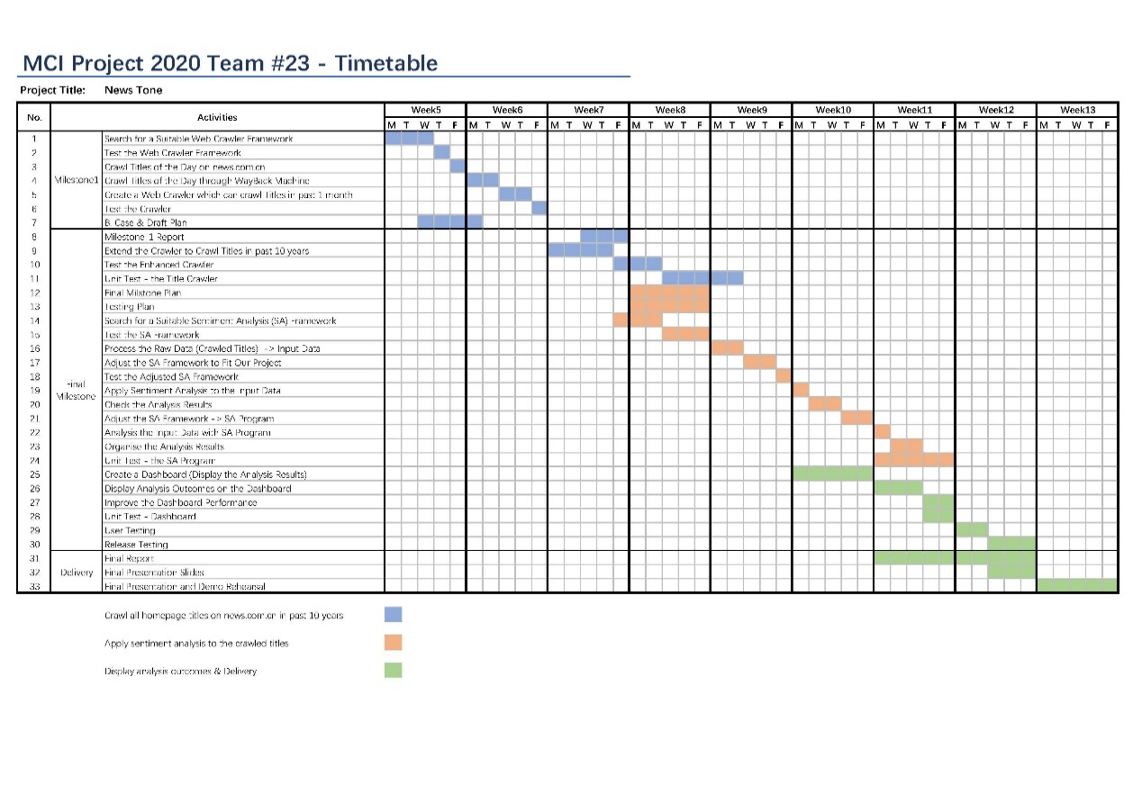

# 4. Communication Plan

We plan to have 2 times of group meetings per week as least to ensure the necessary communications and discussions, and 1 time contact with supervisor at least to ensure the program is on track and schedule.

# 5. Issues

|  |  |  |
| --- | --- | --- |
| **Issue** | **Status** | **Notes** |
| Gathering input materials and extracting subjective information from websites. | In progress | One of the most important parts of search engine is WebCrawler which can get the original information from network for the search engine. |
| Use huge pools of data to help train sophisticated machine learning algorithms. | In progress | This is the core of the sentiment analyzing program. It determines the accuracy of the algorithm of sentiment analysis. |

# 6. Evaluation criteria

## 90% of test cases result could match with human.

## Walkthrough of iteration build with supervisor received favorable response.

## Favorable response to technical demo.